Care Standards Act 2000 - Registration Enquiry Form

Please use this form to tell us about the service you are looking to provide. To help us decide whether you need to apply to be registered with Healthcare Inspectorate Wales (HIW) please answer all the questions and provide as much information as possible.

Please return the completed form either by e-mail to Hiw.registration@gov.wales or alternatively you can send a hard copy to Registration Team, Healthcare Inspectorate Wales, Welsh Government, Rhydycar Business Park, Merthyr Tydfil, CF48 1UZ.

We will make a decision based on the information you provide in this form. However, if your circumstances change in any way following our response you should check with us again.

To carry on or manage a registerable independent health care service or private dental practice without being registered with HIW is an offence under section 11 of the Care Standards Act 2000. Failure to register when required to do so may result in legal action being taken against you.

Service / Practice name
Service / Practice address

Name

Email

Telephone number

Date enquiry form completed

- What services / treatments do you intend to provide? Please describe.

- Will any of the services / treatments fall into the following categories?

Yes/No
Cosmetic surgery:
i.e. Breast enlargements (implants); breast reduction (male & female); surgical fat transfer; facelift (rhytidectomy); ear correction surgery (including ear pinning); tummy tuck (abdominoplasty); nose reshaping (rhinoplasty); liposuction; hair transplant; labiaplasty (vulval surgery); eyelid surgery (blepharoplasty).
Endoscopy
Haemodialysis or peritoneal dialysis
Hyperbaric therapy
In vitro fertilisation (IVF) techniques
Male circumcision
Medical treatment under general anaesthesia or (intravenously administered) sedation
Medical or psychiatric treatment for illness or mental disorder or palliative care
Obstetric services, and in connection with childbirth, medical services
Termination of pregnancies
Treatment and/or nursing for persons liable to be detained under the Mental Health Act 1983
Treatment using a Class 3B or 4 laser or an Intense Pulsed Light (IPL) device

Please provide evidence that confirms the type of device and the class of laser used.
The manufacturer will be able to confirm the class of the laser. We recommend you contact the Medicines and Healthcare products Regulatory Agency (MHRA) who will be able to confirm if the device complies with legal requirements.
Subcutaneous injection of a substance or substances into the skin for medical reasons e.g. to treat migraine, excessive sweating
Weight loss management services
Dental treatment under general anaesthesia
Private and NHS dental treatment
Private dental treatment
Private dental treatment using a Class 3B or 4 laser

Please provide evidence that confirms the type of device and the class of laser used.
The manufacturer will be able to confirm the class of the laser. We recommend you contact Medicines and Healthcare products Regulatory Agency (MHRA) who will be able to confirm if the device complies with legal requirements.
Service by a dental hygienist, dental therapist or clinical dental technician via direct access arrangements
Other (Please give details)

- Are the services / treatments to be provided in Wales?

Yes
No

- Where will the services / treatments be provided?

Yes/No
Business premises (e.g. hospital, clinic, salon) located in Wales
Multiple business premises (e.g. hospitals, clinics, salons) located in Wales
Treatment room at your own home (e.g. outbuilding, annex, converted room) located in Wales
Inside patients’ own homes
Via an online platform (If yes, see question 5)
Other (please give details)

- If patients are only seen remotely (online), is the company/business address in Wales?

Yes
No

- How often will services / treatments be provided / offered?

Weekly
Fortnightly
Monthly
On an ad-hoc basis / no pattern
Other (please give details)

- Are any of the services / treatments to be provided to patients / clients on behalf of the NHS?

Yes
No
Other (please give details)

- Who will provide the services / treatments?

Yes/No
Medical Practitioner (i.e. a doctor or a consultant registered with the General Medical Council and who holds a licence to practise)
Healthcare Professional (e.g. Nurse, Physiotherapist, Pharmacist, Podiatrist)
Dentist
Dental Care Professional (e.g. Hygienist, Therapist, Clinical Dental Technician, Dental Technician)
Non-healthcare Professional (e.g.Beauty Therapist)
Other (please give details)

- Will a medical practitioner (i.e. a doctor or a consultant registered with the General Medical Council and who holds a licence to practise) be involved in the services / treatments to be provided?

Yes
No
If Yes, please give details on the extent of this involvement

- If prescription only medicines are used, please indicate whether a medical practitioner or a healthcare professional (e.g. Nurse Prescriber, Pharmacist) will prescribe these

Yes/No
Medical Practitioner (i.e. a doctor or a consultant registered with the General Medical Council and who holds a licence to practise)
Nurse Prescriber
Pharmacist
Other (please give details)

- How will patients / clients access the services / treatments?

Yes/No
Self referral
Referred by a medical practitioner, dentist or other healthcare professional
Referred by their employer
Referred by an insurance company
Other (please give details)

Privacy notice

For details of how HIW uses your personal information please read our full Privacy Notice available at www.hiw.org.uk.

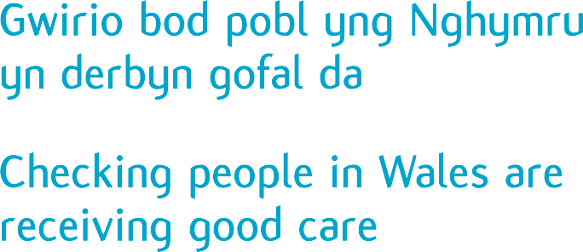
Llywodraeth Cymru / Welsh Government
Parc Busnes Rhydycar / Rhydycar Business Park
Merthyr Tudful / Merthyr Tydfil
CF48 1UZ
Tel / Ffôn 0300 062 8163
www.hiw.org.uk

